**INTERNSHIP REPORT**

Submitted in partial fulfillment of requirement

for the award of the degree

MASTER OF COMPUTER APPLICATIONS

of

Visvesvaraya Technological University, Belagavi

By

(PRAJWAL B S 4NM20MC063)

2020-2022



(An Autonomous Institution affiliated to VTU, Belagavi)

Nitte Mahalinga Adyanthaya Memorial Institute of Technology

Nitte – 574110, Karkala, Udupi District

**INTERNSHIP REPORT**

Submitted in partial fulfillment of requirement

for the award of the degree

MASTER OF COMPUTER APPLICATIONS

of

Visvesvaraya Technological University, Belagavi

By

(PRAJWAL B S 4NM20MC063)

2020-2022

Under the guidance of

**Dr Aravind Kumar**

**Research Scientist**

**Exposys Data Labs**

(Duration :3rd February,2022 to 2nd March,2022)



(An Autonomous Institution affiliated to VTU, Belagavi)

Nitte Mahalinga Adyanthaya Memorial Institute of Technology

Nitte – 574110, Karkala, Udupi District

Nitte Mahalinga Adyanthaya Memorial Institute of Technology

Nitte – 574110, Karkala, Udupi District

2020-2022



(An Autonomous Institution affiliated to VTU, Belagavi)

CERTIFICATE

This is to certify that the project entitled

Driver Drowsiness Detection

Submitted in partial fulfillment of requirement

For the award of the degree

MASTER OF COMPUTER APPLICATIONS

Is result of the bonafide work carried by

PRAJWAL B S 4NM20MC063

During the academic year 2021-2022

Internal Guide

Mrs. Sarita Shetty Dr. Surendra Shetty

Assistant Professor Professor & Head

Department of MCA Department of MCA

NMAM Institute of Technology, Nitte NMAM Institute of Technology, Nitte

**ABSTRACT**

I did my internship at Exposys Data Labs under the guidance of **Mr. ARAVIND R&D ENGINEER EXPOSYS DATA LABS.** It was around 35 days internship; the topic was given by them only. I have chosen web development, so I get develop an application about Video calling. I developed a video calling app through android studio. I have made some research about that because there are lot updates in android studio so old technology won’t work so. I have used an external sdk for making calls. And also we can chat.

Table Of Contents

|  |  |  |
| --- | --- | --- |
| S.NO | Title | Page No |
| 1 | Acknowledgement | 01 |
| 2 | About Organization | 02 |
| 3 | Internship Position | 04 |
| 4 | Internship Experience | 05 |
| 5 | Screenshots | 06 |
| 6 | Conclusion and References | 10 |
| 7 | Reference | 11 |
|  | | |

**ACKNOWLEDGEMENT**

We would like to express our special thanks of gratitude to our supervisor **Mr. ARAVIND R&D ENGINEER EXPOSYS DATA LABS** who gave us the golden opportunity to do this wonderful project on Android Applications, which also helped us in doing a lot of research and we came to know about so many new things about android. We are really thankful to Exposys Data Labs for creating this wonderful opportunity to explore our potential in Software development.

PRAJWAL B S

**ABOUT ORGANIZATION**

Exposys is Bangalore based company. It is one among the forerunners who launched the new generation of Digital Learning platform in India. We strategies technology-enhanced educational instructional practice by grooming Aspirants domain skills with cutting edge technologies and processes to help them become industry ready Technocrats and Business Managers.

Exposys Data Labs is a promising corporate pool of talent drawn from the Alumni of IITs and NITs who have joined together with a sole commitment of serving their following generation of Aspirants. We have become second to none as the fast-growing professional training platform by providing top-class real time internships and certification programs which have yielded some great results: around 50,000+ students trained,1+ million hours of training,30+ specialized professional courses.

The provide These courses:

* Web Development

Exposys Data Labs is focused on helping brands grow through digital transformation services. Our software and hardware, design and development services range from business-critical applications to powerful Augmented and Virtual Reality applications that push the boundaries of consumer, industrial, experiential, and commerce applications for the world’s most innovative brands as a recognized global leader in development and design, our proactive growth model empowers our clients to exceed their goals while integrating our team with theirs.

* Machine Learning

Exposys Data Labs helps to builds best machine learning model’s and give interns great idea how to develop a model from scratch and how to use machine learning algorithm and where to use it.

* Robotics

Introduces us to the ever-evolving robotics world, starting with the variety of robotic arms and their wide applications. Introduces us to the ever-evolving robotics world, starting with the variety of robotic arms and their wide applications.

**Internship position**

As an intern with Exposys, I worked with project called Video calling application. It’s up to me chose the language and platform for developing the project, So I decided ang go with Android Studio using java as language. It was not a group project so I was both frontend as well as backend developer. In android studio we use different techniques for design as well as coding in xml we design required design.

For backend we used google firebase. To enable this, we have done some research we do need to have recent version of android studio otherwise it’ll become a bit risky to handle as well as reach firebase when progress was made. To maintain the database, we have to always stay connected otherwise it’ll expire a given time.

**Internship Experience**

During my internship with the Exposys company, I learned about android studio and its components and design and understand layout and how to style the contents as well as coding I used java as language so I did learn more about that. I was able to put these skills in practice in projects. I learned about firebase as well. I used it has backed to store the database so I learned how to create a database in firebase and how to create particular design as well as who can see the data how much details are needed and also about verification. I used email password for login as well as registration so verification so important in the process.

The work was challenging, and I learned [mention what you learned] about the work and gained more confidence in myself. It was a valuable experience.

SCREENSHOTS 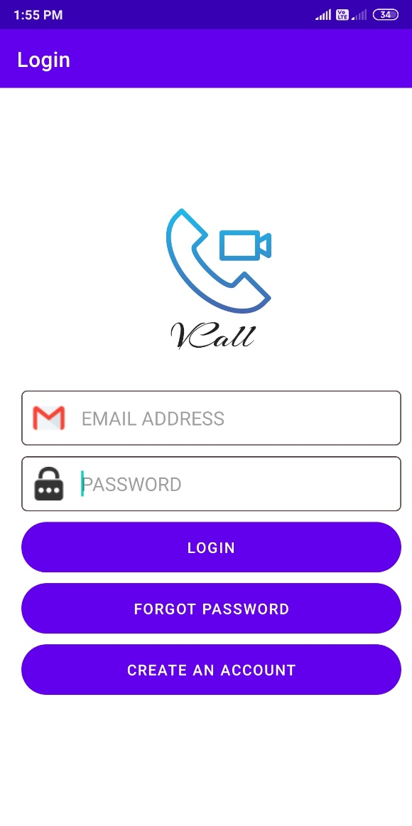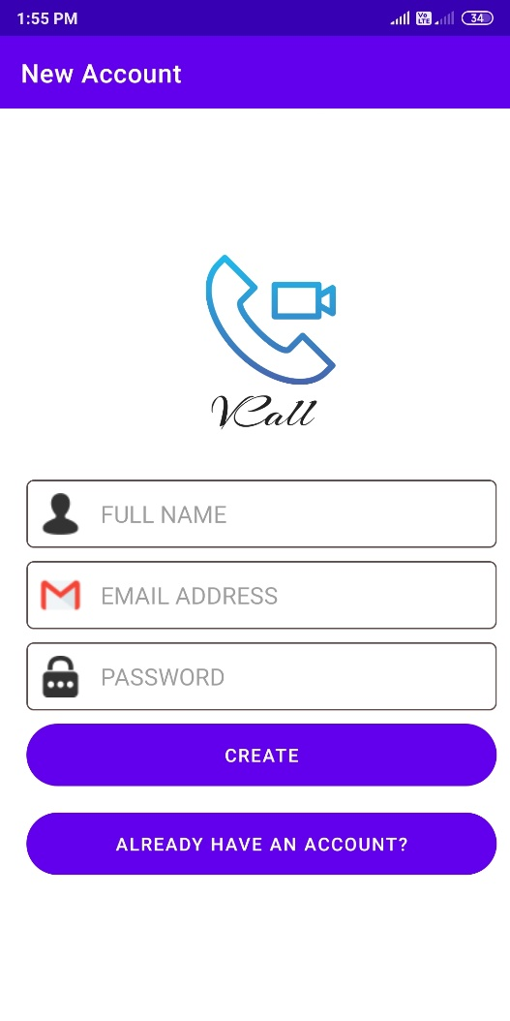

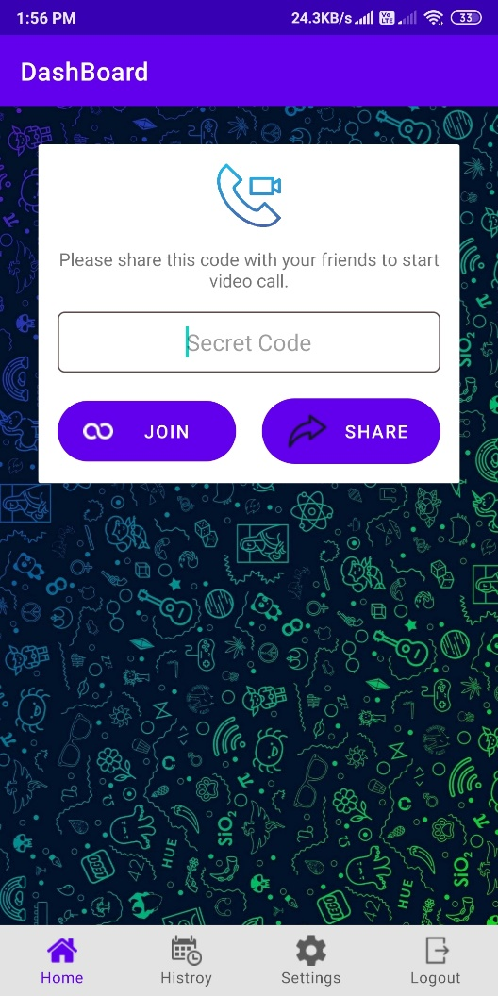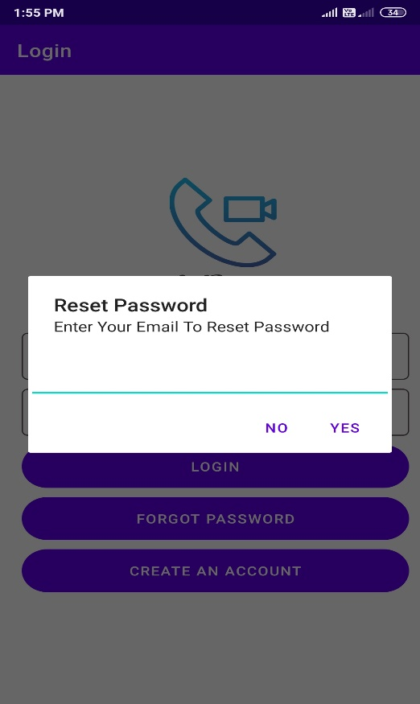

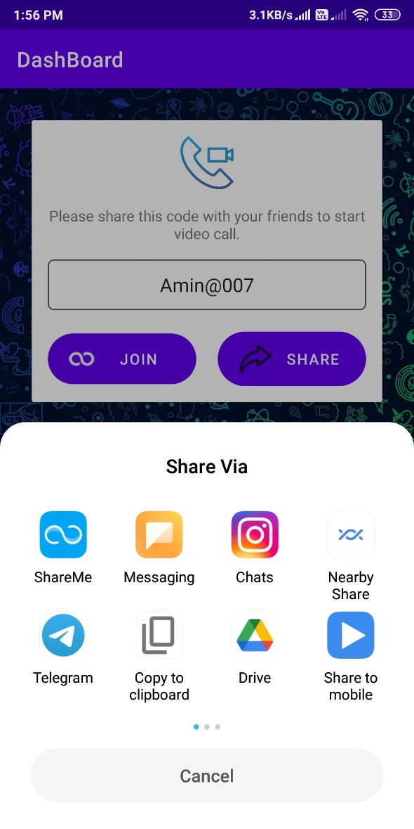

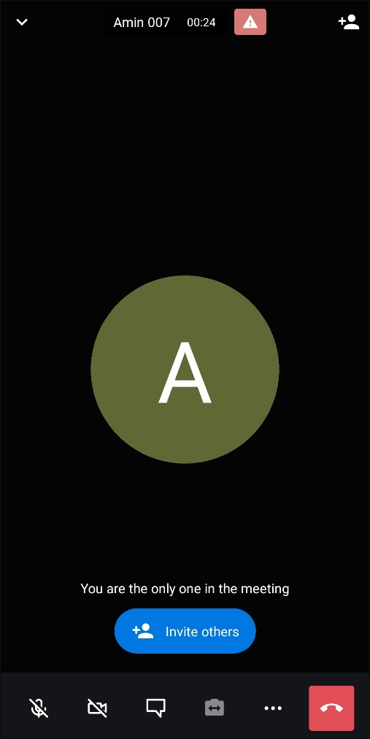

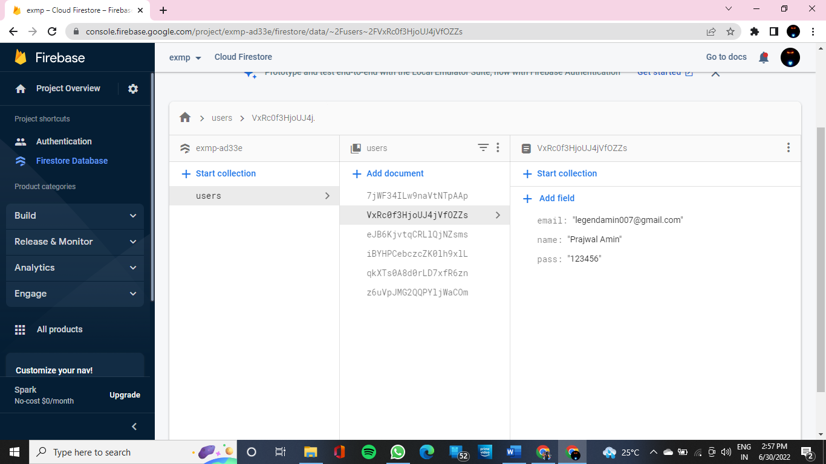

CONCLUSTION

Android as a full, open and free mobile device platform, with its powerful function and good user experience rapidly developed into the most popular mobile operating system. This report gives an overview of the different challenges and issues faced in android app development The experience of developing an android app is quite challenging, motivating as well as satisfying. There are already several application for video calling app with enhancement this could be a good application for feature.

**REFERENCE**

<https://developer.android.com/studio/releases/gradle-plugin-roadmap>

<https://developer.android.com/studio/intro/studio-config>

<https://www.youtube.com/watch?v=B_xSuk8Heew&t=3060s>

<https://console.firebase.google.com/project/exmp-ad33e/authentication/users>